Alyssa Basile

Southern New Hampshire University

22 May 2022

Module 3 Journal

Journal

Some of the best data analysis techniques to use for this problem are descriptive statistics and graphical analysis. I chose descriptive statistics because what it means is we are gathering the data to describe what it is or what it shows (Trochim) and the data we are trying to obtain are quantitative (numerical) data. Using graphs to demonstrate the data will help give us the bigger picture of what the statistics show, which is why I also chose graphical analysis for this problem.

We want to find the answer to the average number of messages by a single username, the average number of reshares by a single username, and the time frame that has the highest number of original messages. The only data we need to use to answer our questions are username, reshares, message, and created_at. We have no use for message_id. To receive the average number of messages by a single username, we need the data from username and message. To receive the average number of reshares by a single username, we need the data from username and reshares. To calculate the highest number of original messages within the time frame, we need the data from created_at and message.

To validate my result, I did the math to calculate the average number of messages by a single username and the average number of reshares by a single username. The average number of messages by a single username is 945.2308 (refer to image 4). To validate, I calculated the number of usernames and there are 26 usernames (refer to image 7) and I divided the sum of messages (264,576 – refer to image 8) by 26 and got 945.2308 as the answer. The average number of reshares by a single username is 7385.5385 (refer to image 5). I used the same method to validate my answer, that is using the sum of reshares (192,024 – refer to image 6) and divide it by the number of usernames (26) and I received the same answer (7385.5385). I created a pivot table and chart to get the result for the time frame with the highest number of original messages and they are shown below:

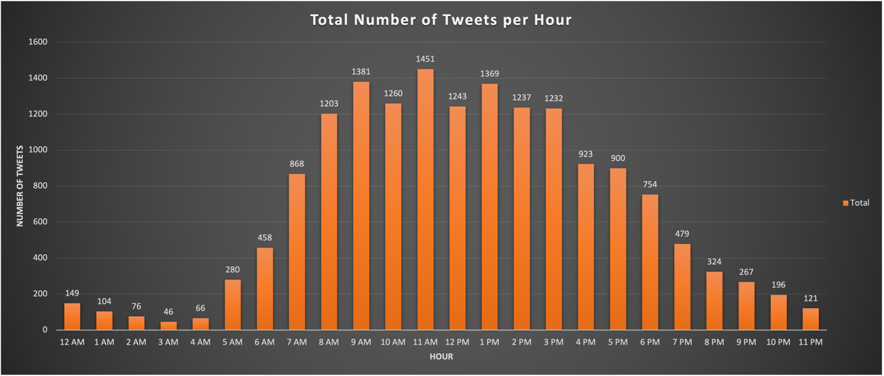

1. Pivot Table of number of tweets per hour.

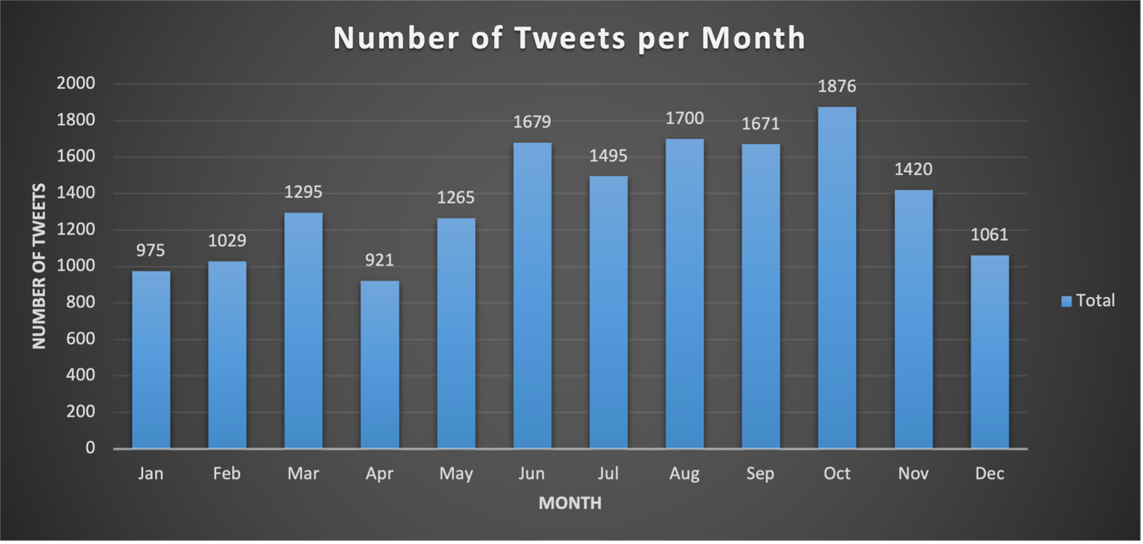

1. Pivot Table of number of tweets per month.

To validate my answer for the graphs, the total number of the original messages are 16,387 (refer to image 9) and referring to image 10 below, there is a total number included in both tables and the total matches to the sum of original messages from the table in MySQL.

SCREENSHOTS:

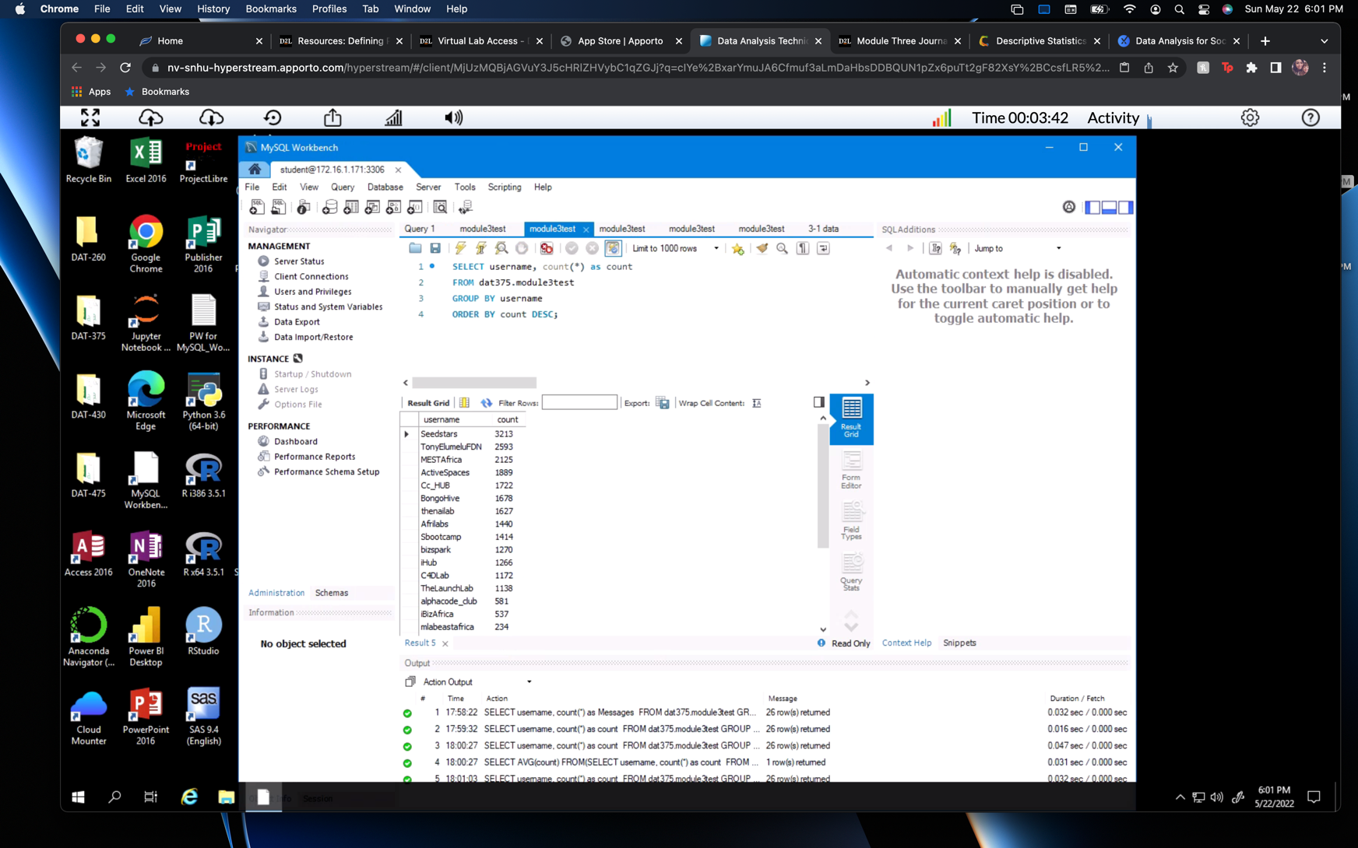

1. Number of tweets from each user in descending order.

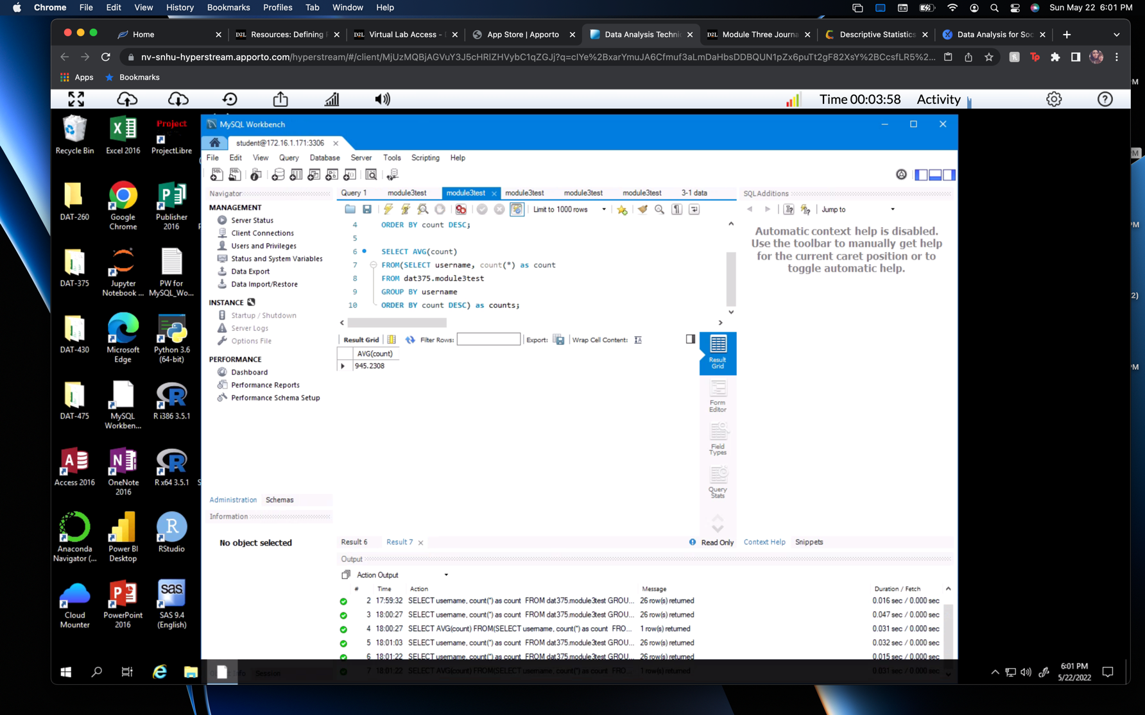

1. Average of messages by a single username (945.2308).

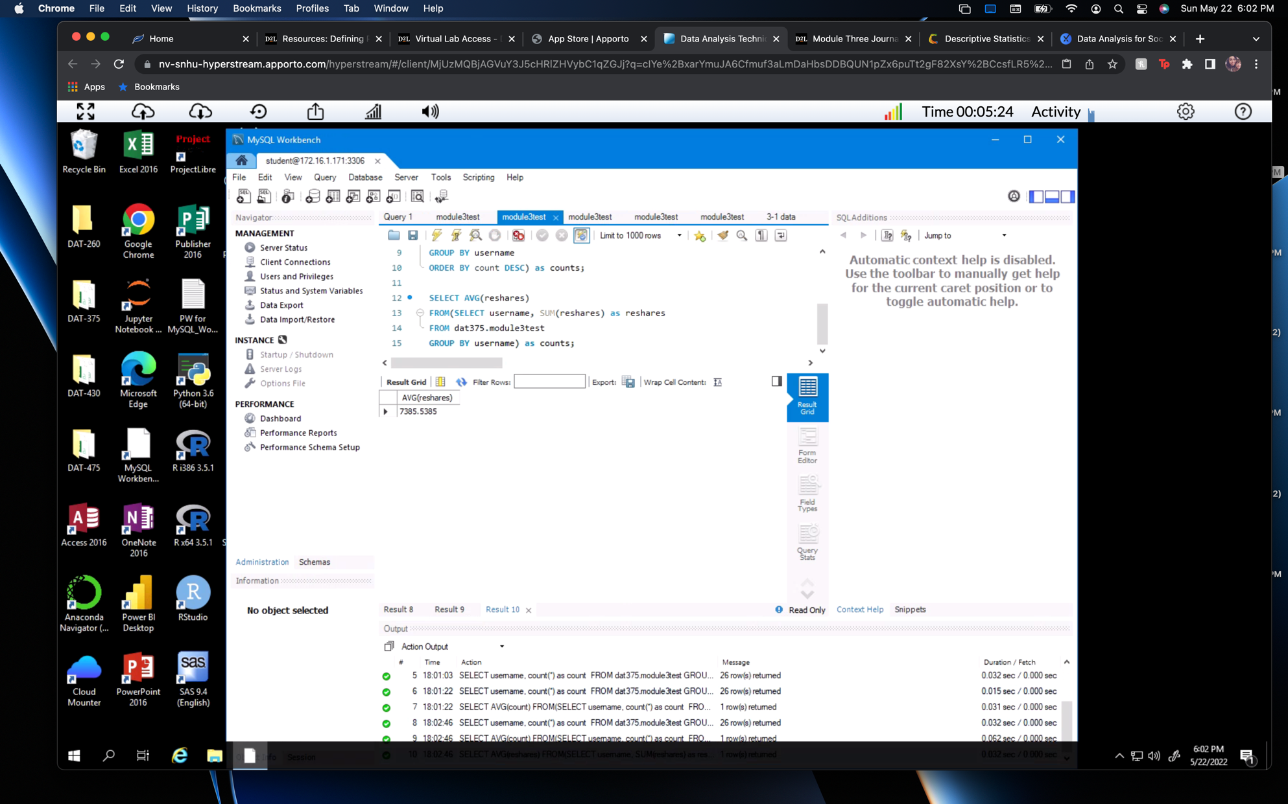

1. The average of reshares by a single username (7385.5385).

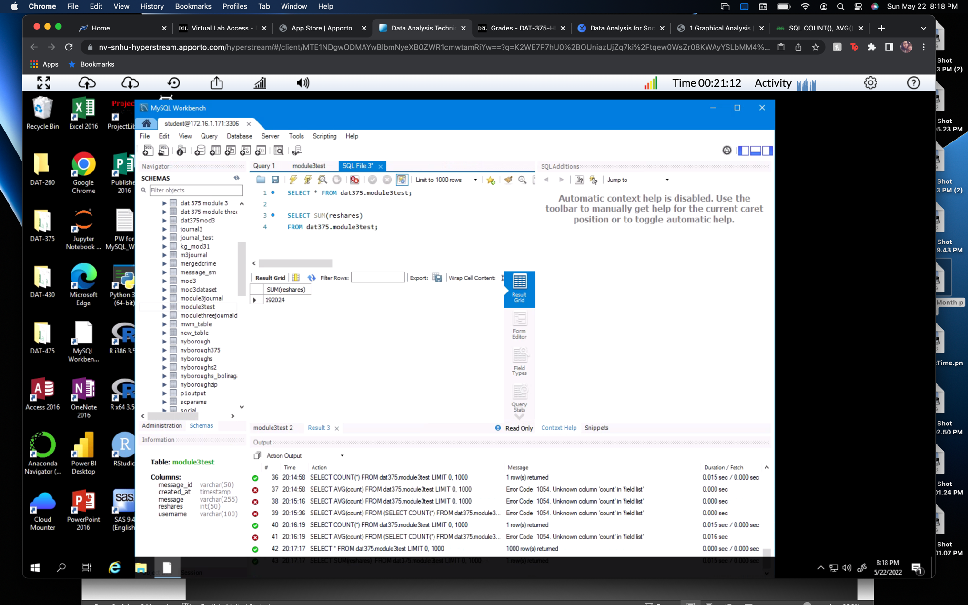

1. The sum of reshares is 192,024.

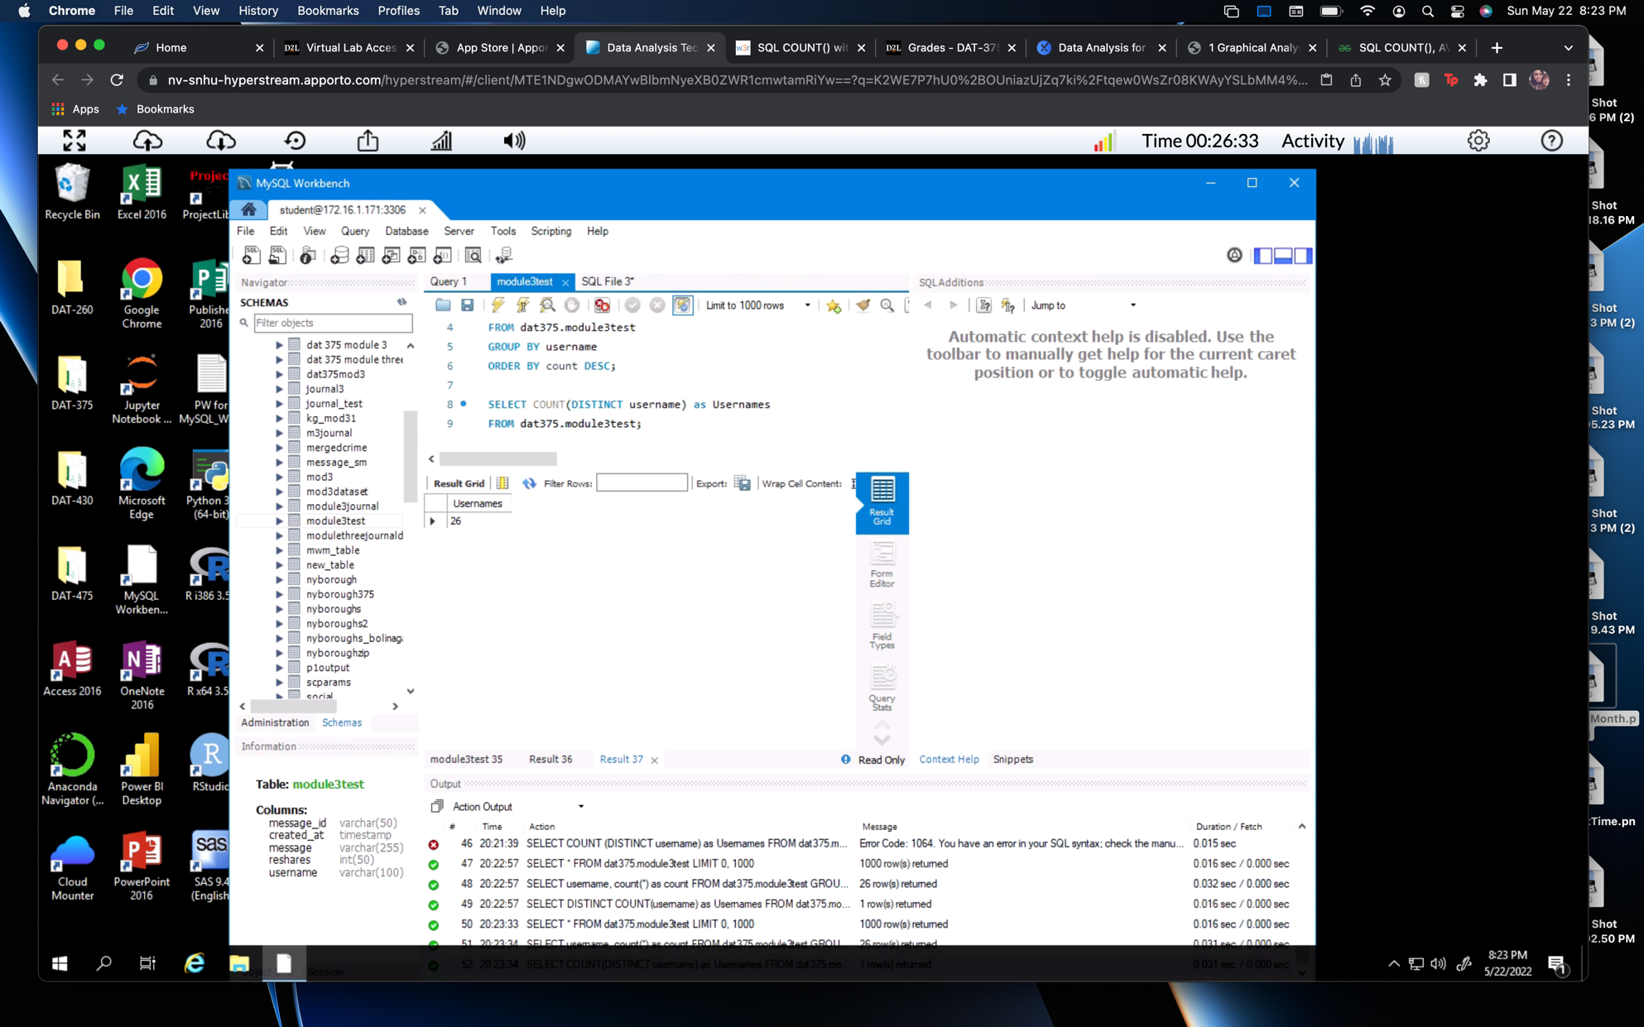

1. The total number of usernames is 26.

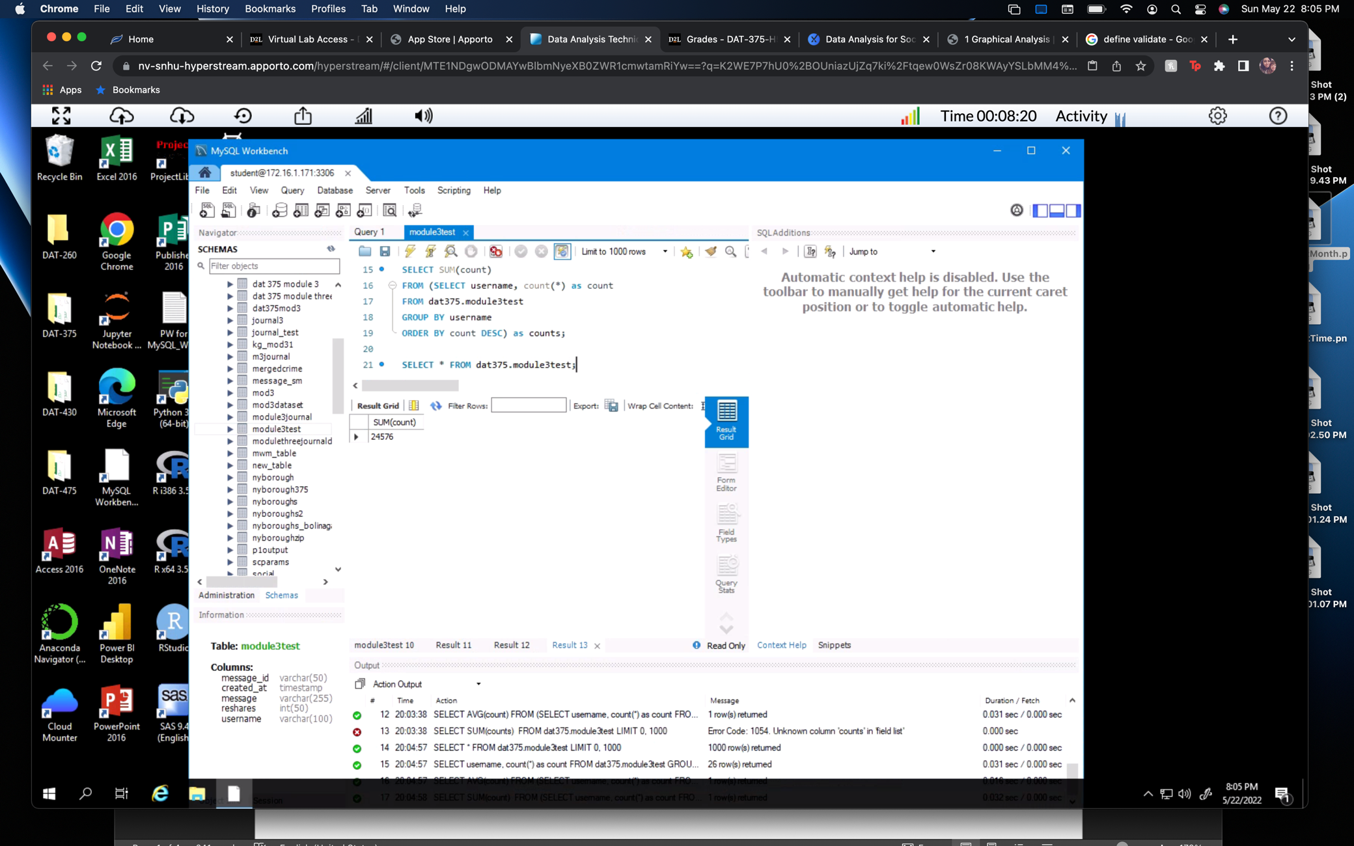

1. The sum of the count is 24,576.

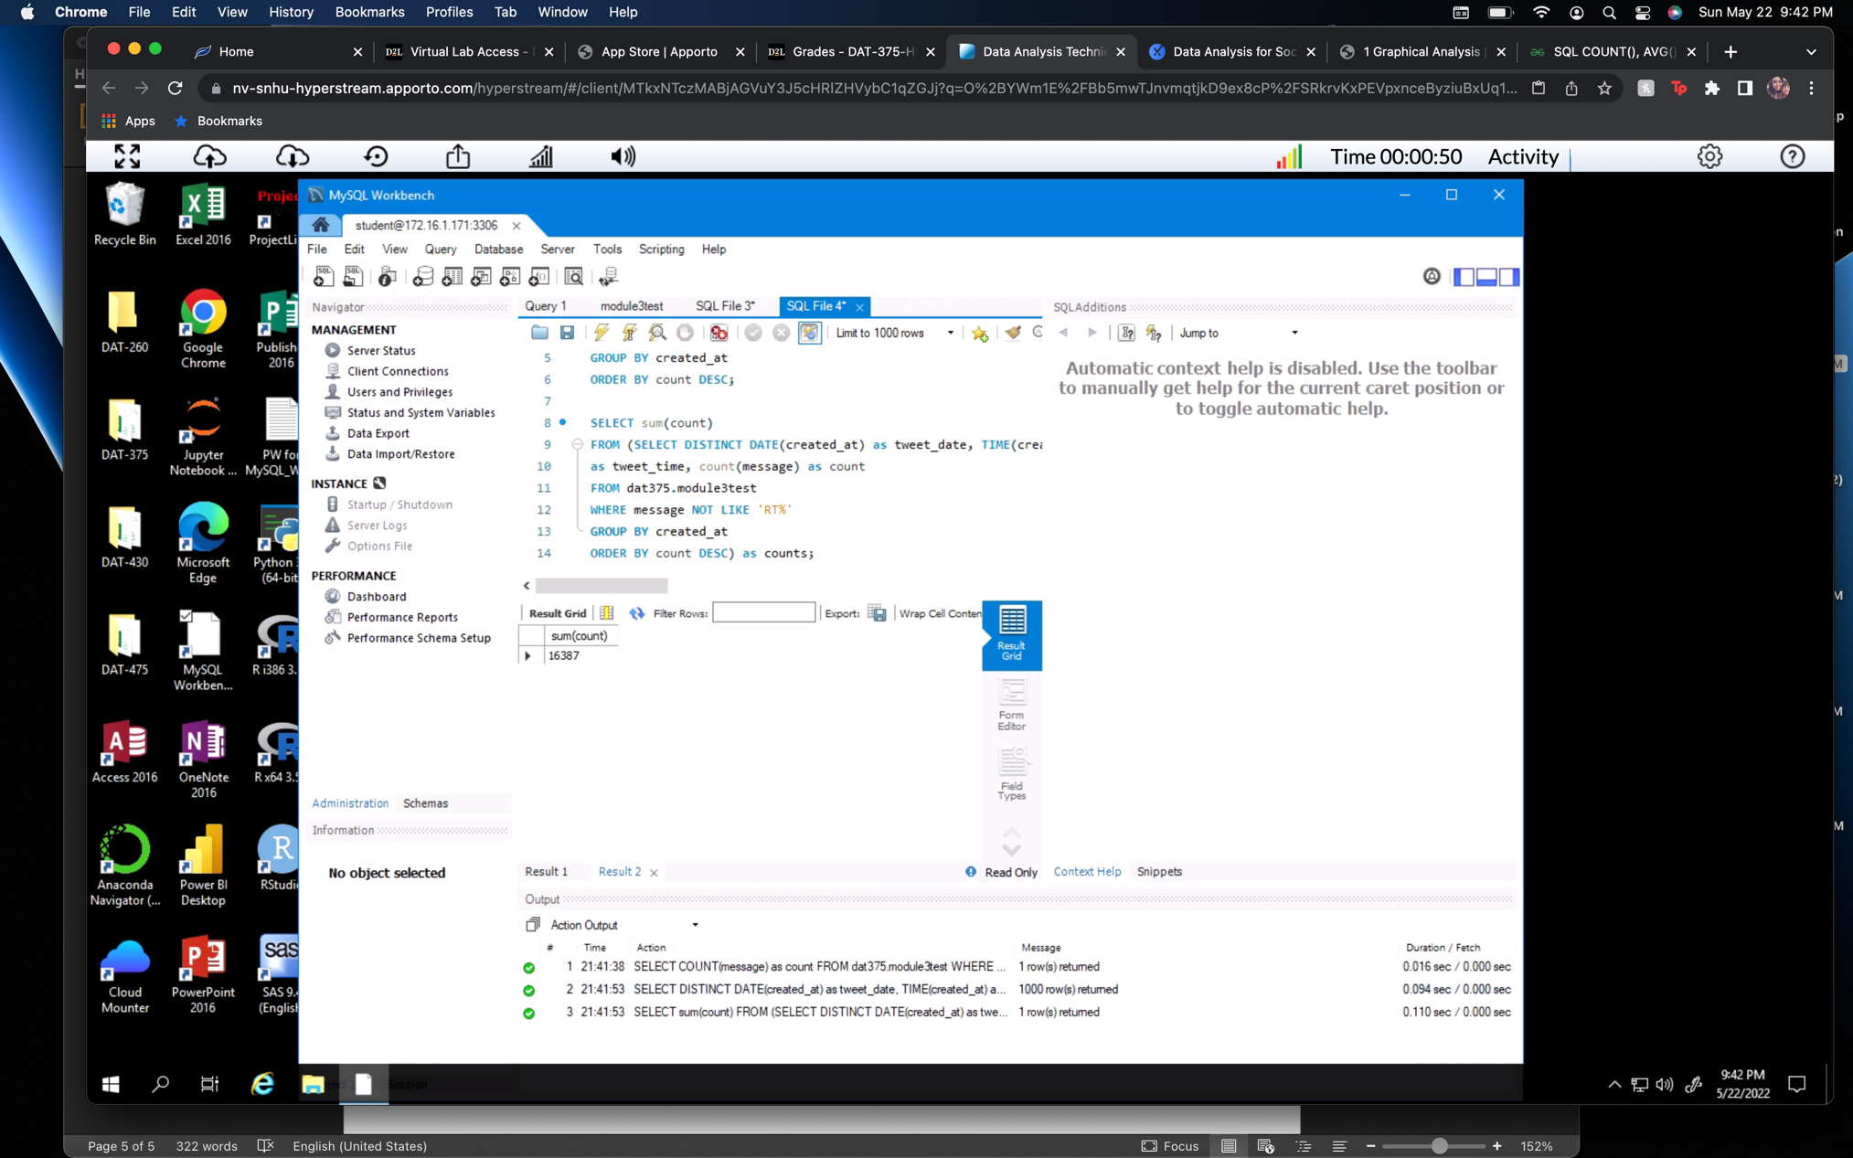

1. Sum of original messages (16,387)

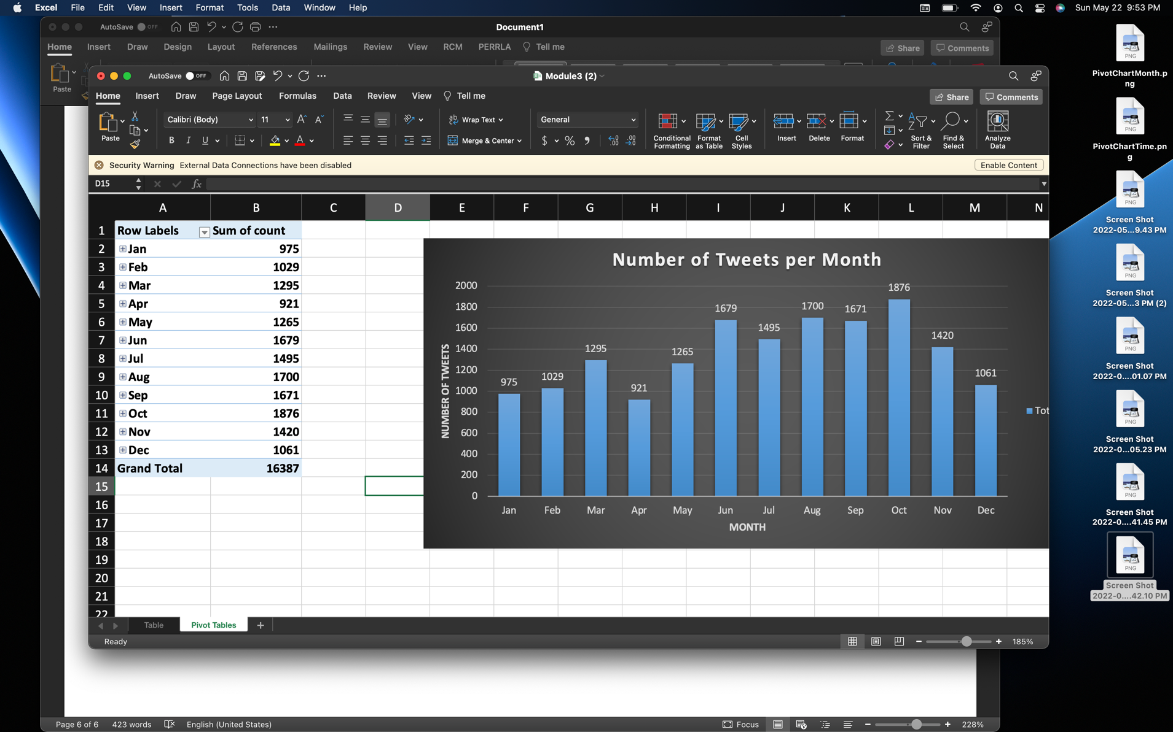 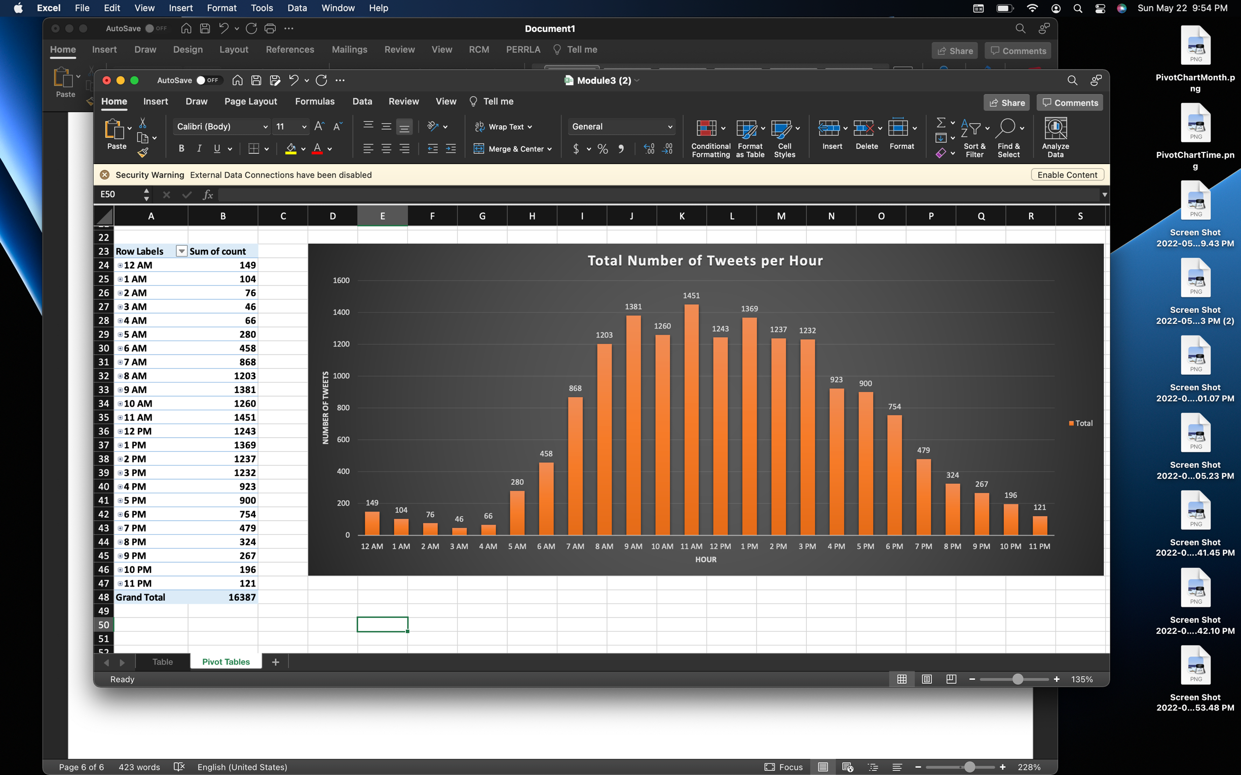

1. Total messages per month and per hour

References:

Hessing, T. *Graphical Analysis*. Six Sigma Study Guide. Retrieved May 22, 2022, from <https://sixsigmastudyguide.com/graphical-analysis/#:~:text=The%20graphical%20analysis%20creates%20pictures,for%20any%20problem%2Dsolving%20method>.

Trochim, W. *The Research Methods Knowledge Base*. Conjointly. Retrieved May 22, 2022, from <https://conjointly.com/kb/descriptive-statistics/>